Week of March 23rd - March27th

This week you will be focusing on the following two TEKS. You have all week to complete the lessons.
8.8(B) explain the central role of the expansion of slavery in causing sectionalism, disagreement over states' rights, and the Civil War;
8.12(C) analyze the causes and effects of economic differences among different regions of the United States at selected times.
Contact

If you have any questions please email your teacher or reach out through Google classroom.
Ms Reyes - mreyes@dickinsonisd.org
Ms. Long - nlong@dickinsonisd.org
Ms. Whelton - hwhelton@dickinsonisd.org
Mr. Lawson -blawson@dickinsonisd.org

Website

These lessons can be completed electronically at https://kranzhistory.weebly.com/ - On the front page look for the “Our most recent lessons” section. Click on the button and it will take you to the starting page.

Name:_______________ | Date:________________ | Teacher:_____________ | Period_______________

Part 1 - Overview

If you can watch the videos below please do so - we have provided the link and a QR code. If you do not have access, either through a smart phone or computer, please continue with the lesson below

https://qrgo.page.link/3Zvoj
https://qrgo.page.link/zPjbV

The Central Role of the Expansion of Slavery in Causing Sectionalism
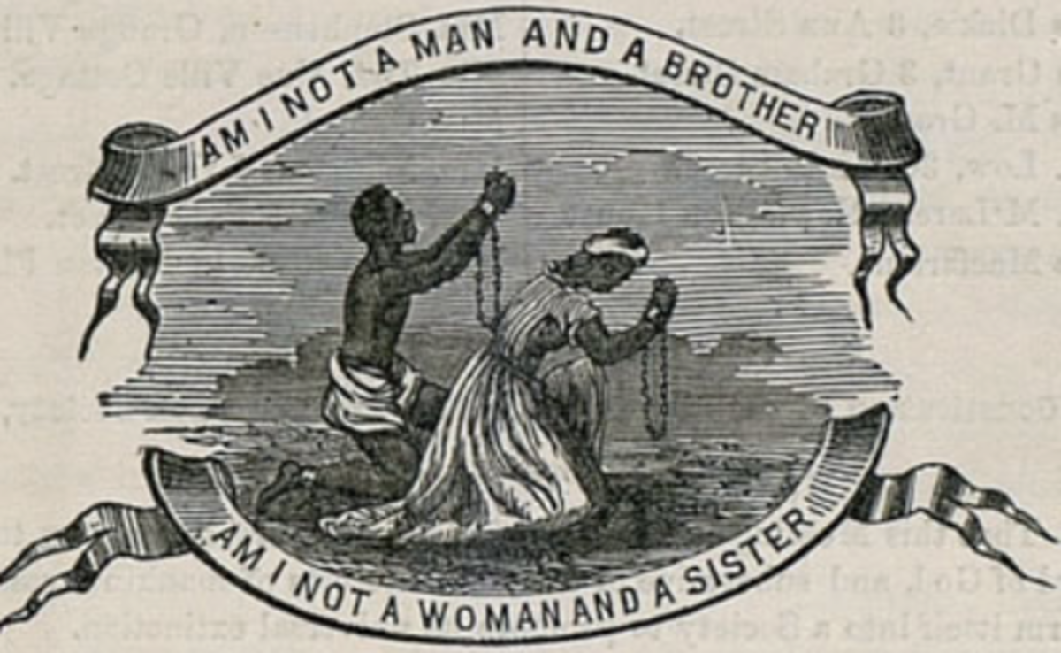
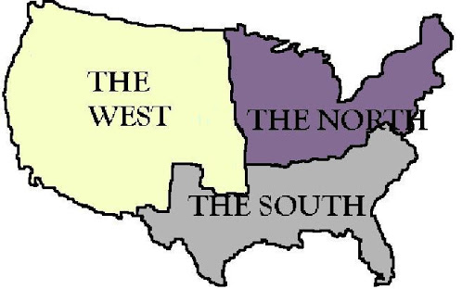
​Slavery--slavery in the United States first began in Virginia during the colonial era. Throughout the first half of the 19th century, southern politicians sought to defend slavery by retaining control of the federal government. The issue of slavery continued to plague the Union as more territory was added, resulting in a division between free states and slave states. Efforts to resolve the conflict over the expansion of slavery into newly organized territories were addressed in the Missouri Compromise, the Compromise of 1850, and the Kansas-Nebraska Act in 1854. It was the 1860 election of Abraham Lincoln that led many political leaders in the South to believe that the federal government was contemplating abolishing slavery.
Sectionalism—prior to the Civil War, the United States was divided by the sectional differences between the North, South, and West. The most pronounced difference was over the issue of enslaving people with the South staunchly defending the need for slave labor
for its agrarian based economy to function
States’ rights—the political position advocating strict interpretation of the Constitution with regard to the limitation of federal powers and the extension of the autonomy of the individual state to the greatest possible degree. Southern political leaders argued that slavery was a states’ rights issue in an effort to protect their common interests.
Civil War—resulted when the Southern states in an effort to protect their interests, most notably the
institution of slavery, seceded from the Union

Check for Understanding
- What was going on in the United States that was causing a division between free states and slave states?_____________________________________________________________
______________________________________________________________________________________________________________________________________________
- List the three efforts to resolve the conflict over the expansion of slavery.
_____________________________________________________________
______________________________________________________________________________________________________________________________________________
- There were sectional differences between the North, South, and West. The most pronounced difference was over the issue of what?
_____________________________________________________________
______________________________________________________________________________________________________________________________________________
- Which section of the United States staunchly defended slavery?
_____________________________________________________________
______________________________________________________________________________________________________________________________________________

Part 2 Sectionalism Image Analysis

If you can watch the video below please do so - we have provided the link and a QR code. If you do not have access, either through a smart phone or computer, please continue with the lesson that follows.

https://qrgo.page.link/osCXC

- The West
Directions: Use the images below - Describe the characteristic of the western region of the country that the picture is displaying.

Example: Image 1: This painting represented the idea of Manifest Destiny.

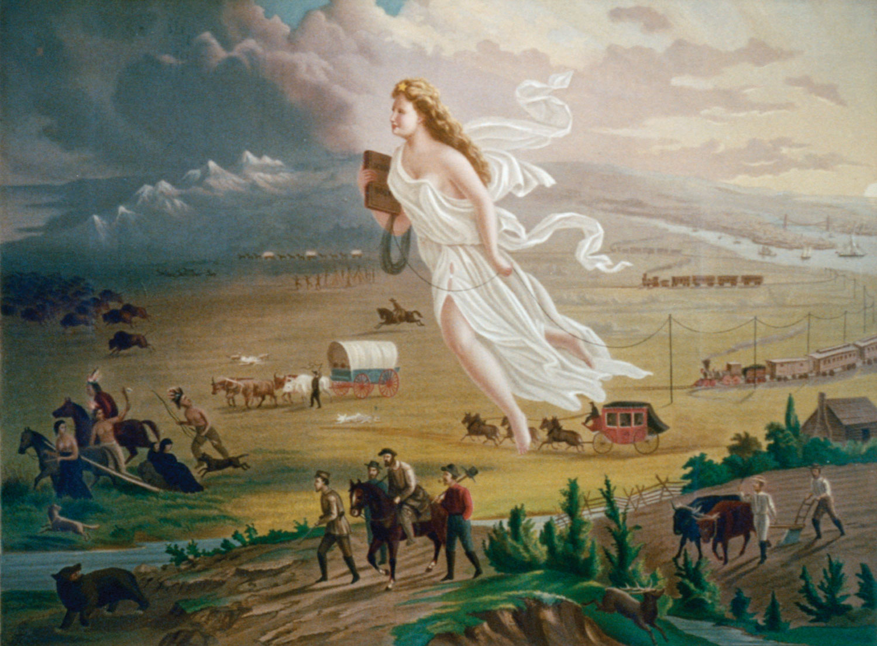 | ____________________________________________________________________________________________________________________________________________________________________________________________________________________________________________________________________________________________________________________________________________________________________________________________________________________________________________________________________________________________________________________________________________________________________________________________________________
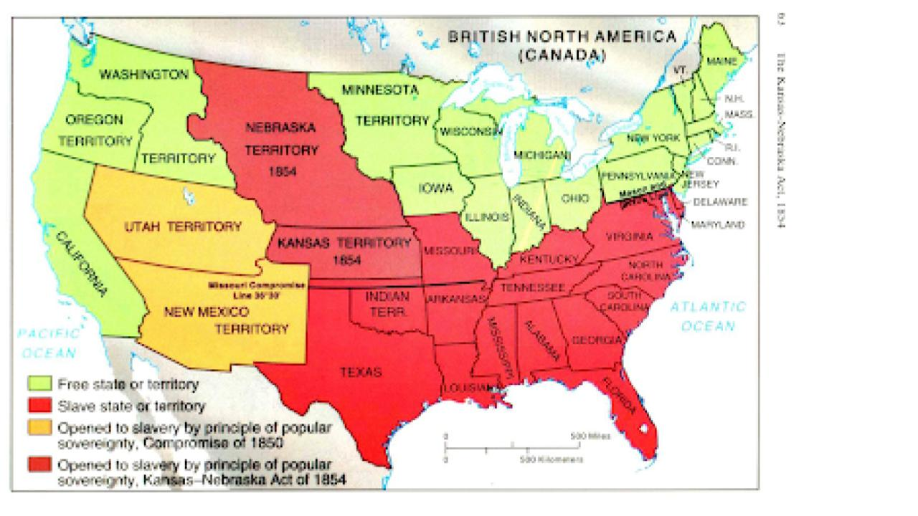 | ____________________________________________________________________________________________________________________________________________________________________________________________________________________________________________________________________________________________________________________________________________________________________________________________________________________________________________________________________________________________________________________________________________________________________________________________________________
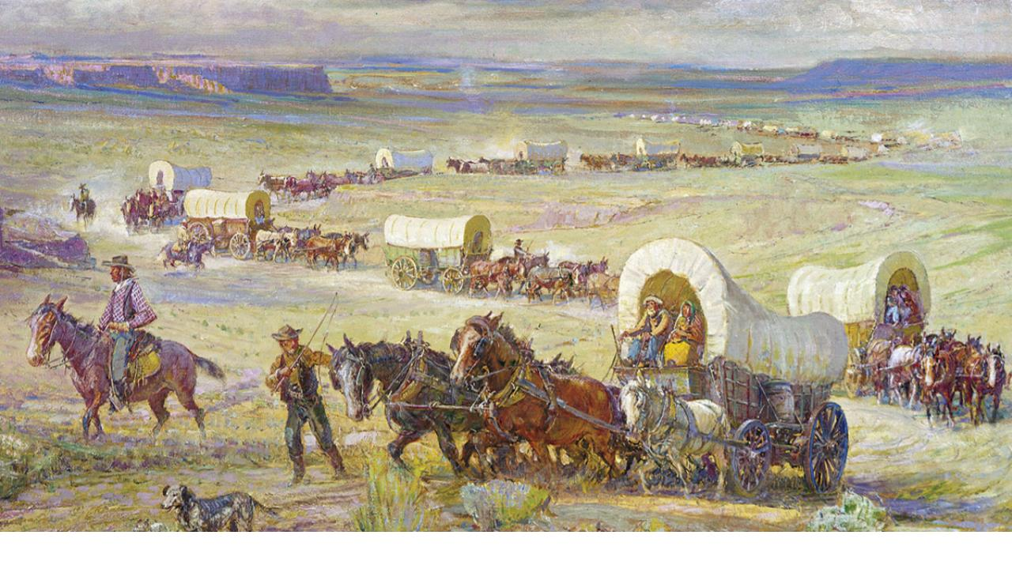 | ____________________________________________________________________________________________________________________________________________________________________________________________________________________________________________________________________________________________________________________________________________________________________________________________________________________________________________________________________________________________________________________________________________________________________________________________________________
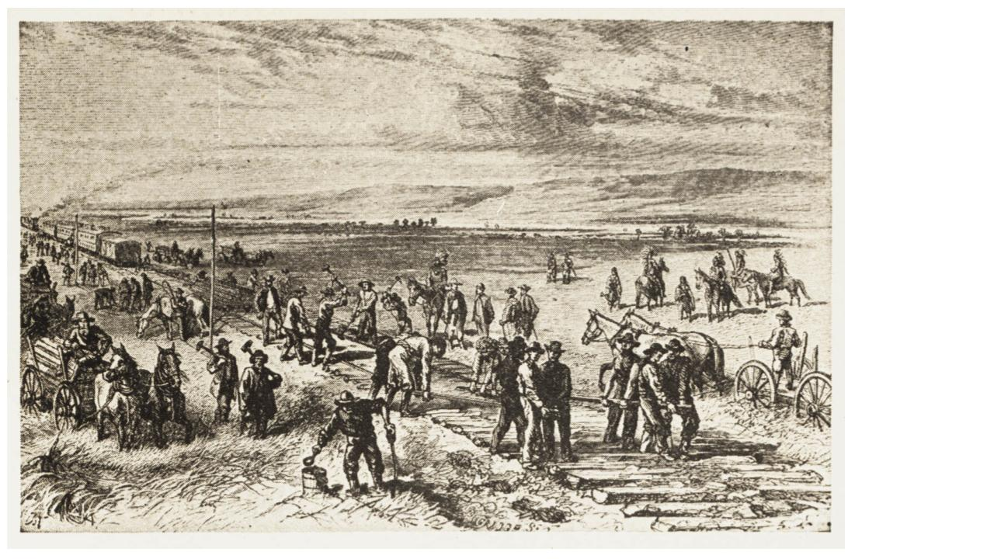 | ____________________________________________________________________________________________________________________________________________________________________________________________________________________________________________________________________________________________________________________________________________________________________________________________________________________________________________________________________________________________________________________________________________________________________________________________________________
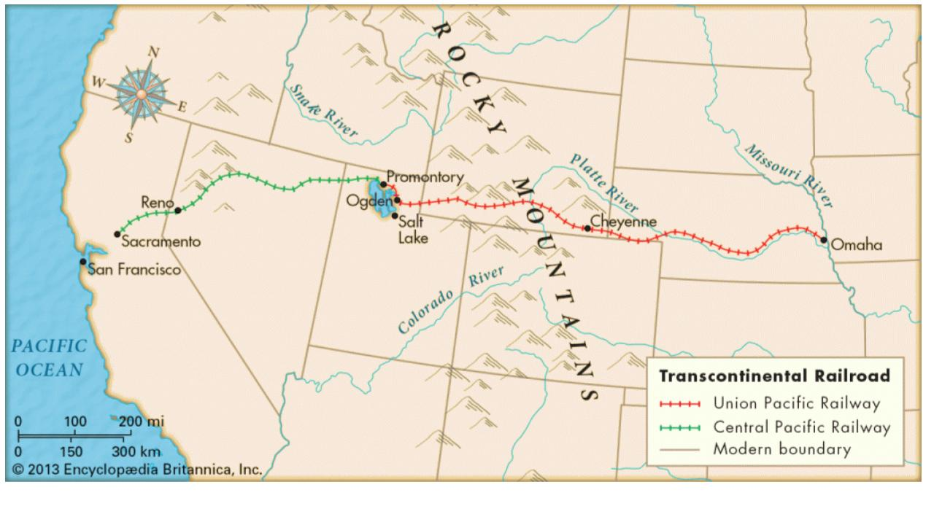 | ____________________________________________________________________________________________________________________________________________________________________________________________________________________________________________________________________________________________________________________________________________________________________________________________________________________________________________________________________________________________________________________________________________________________________________________________________________
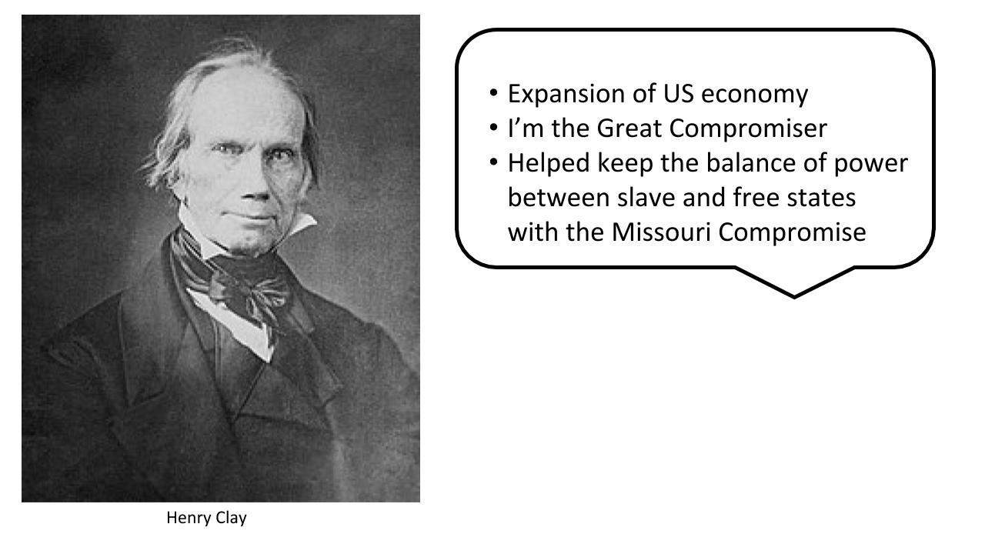 | ____________________________________________________________________________________________________________________________________________________________________________________________________________________________________________________________________________________________________________________________________________________________________________________________________________________________________________________________________________________________________________________________________________________________________________________________________________

- The South
Directions: Use the images below - Describe the characteristic of the southern region of the country that the picture is displaying.

Example: Image 1: Cotton was a cash crop in the south.

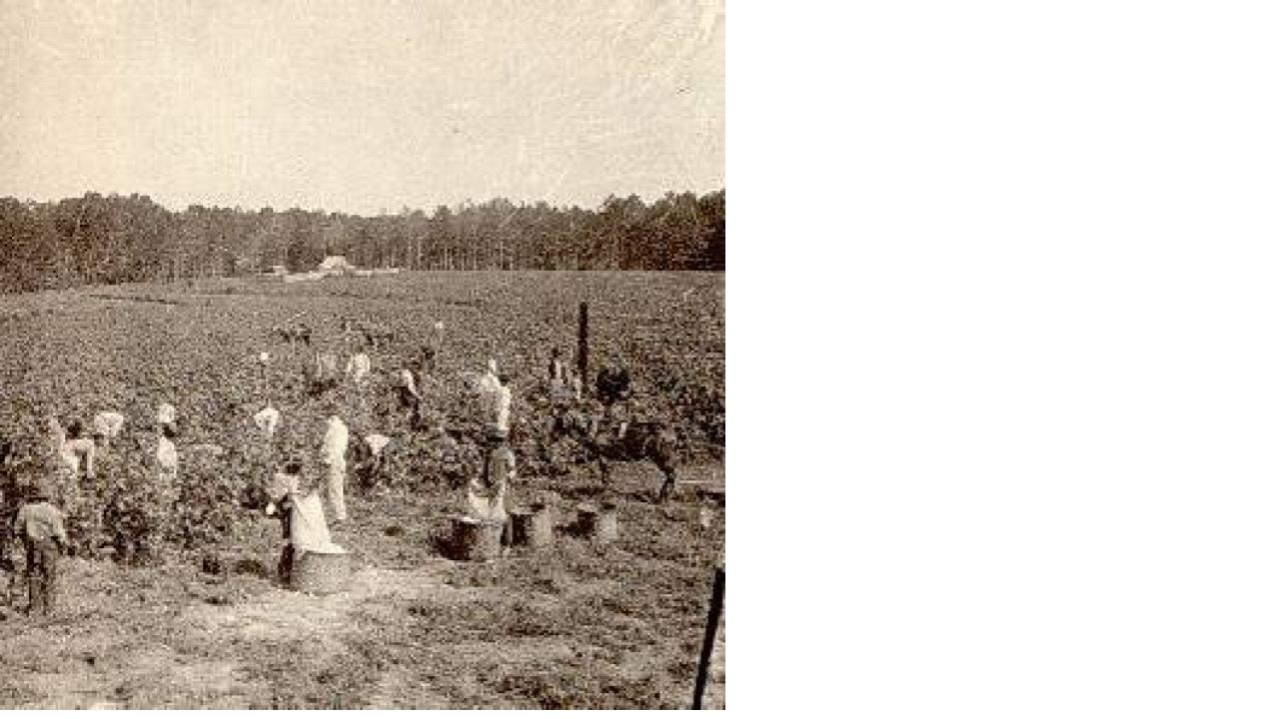 | ____________________________________________________________________________________________________________________________________________________________________________________________________________________________________________________________________________________________________________________________________________________________________________________________________________________________________________________________________________________________________________________________________________________________________________________________________________
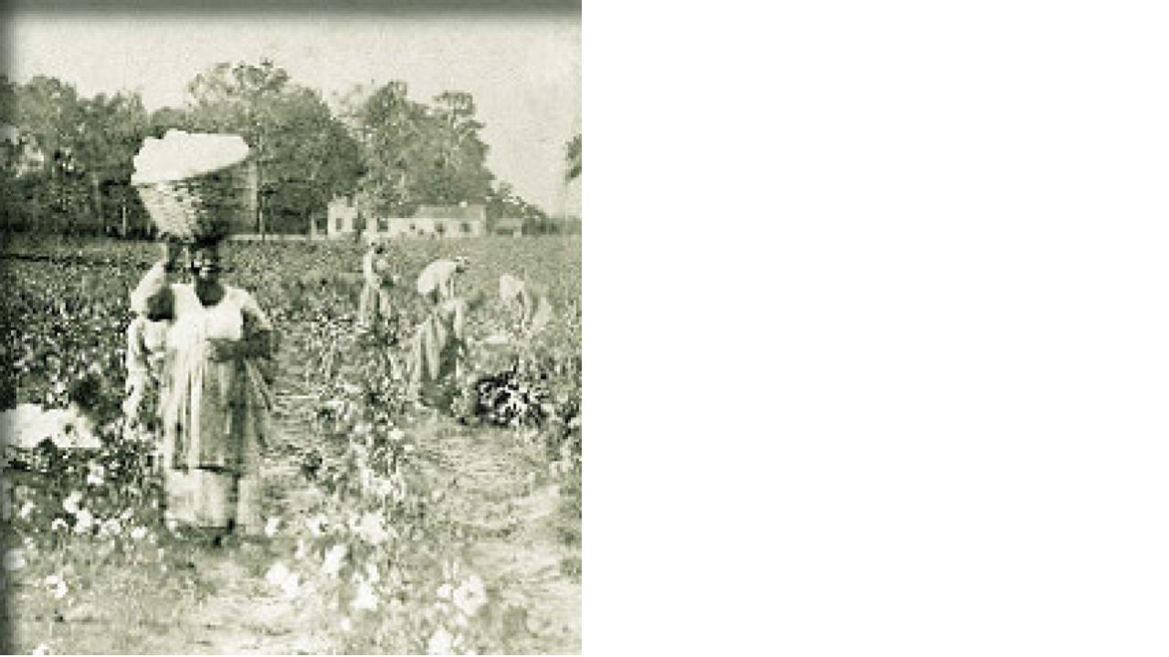 | ____________________________________________________________________________________________________________________________________________________________________________________________________________________________________________________________________________________________________________________________________________________________________________________________________________________________________________________________________________________________________________________________________________________________________________________________________________
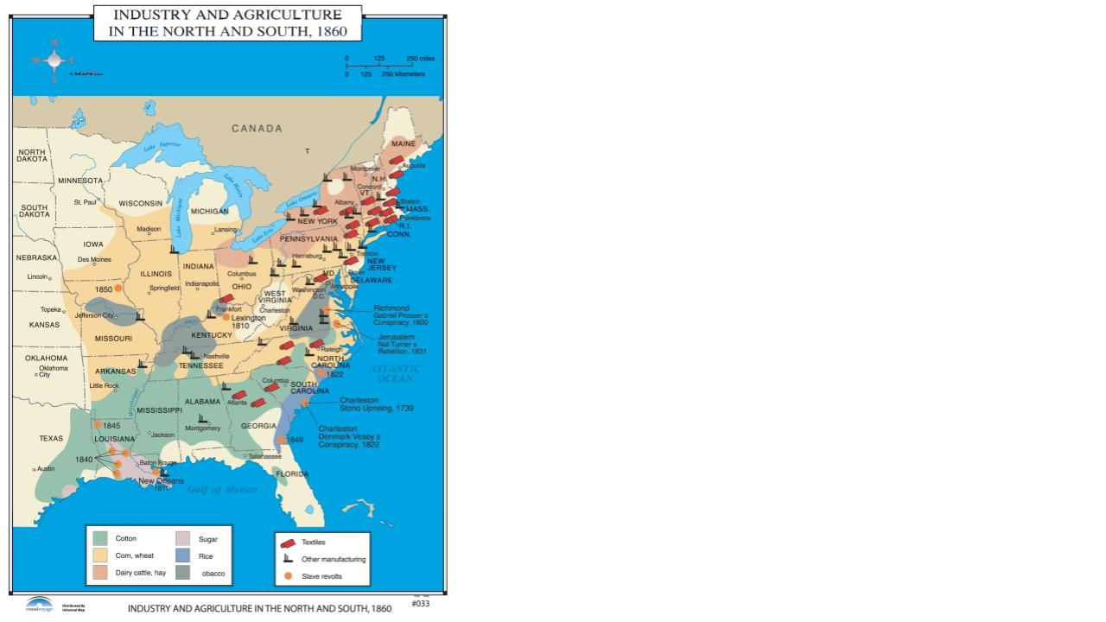 | ____________________________________________________________________________________________________________________________________________________________________________________________________________________________________________________________________________________________________________________________________________________________________________________________________________________________________________________________________________________________________________________________________________________________________________________________________________
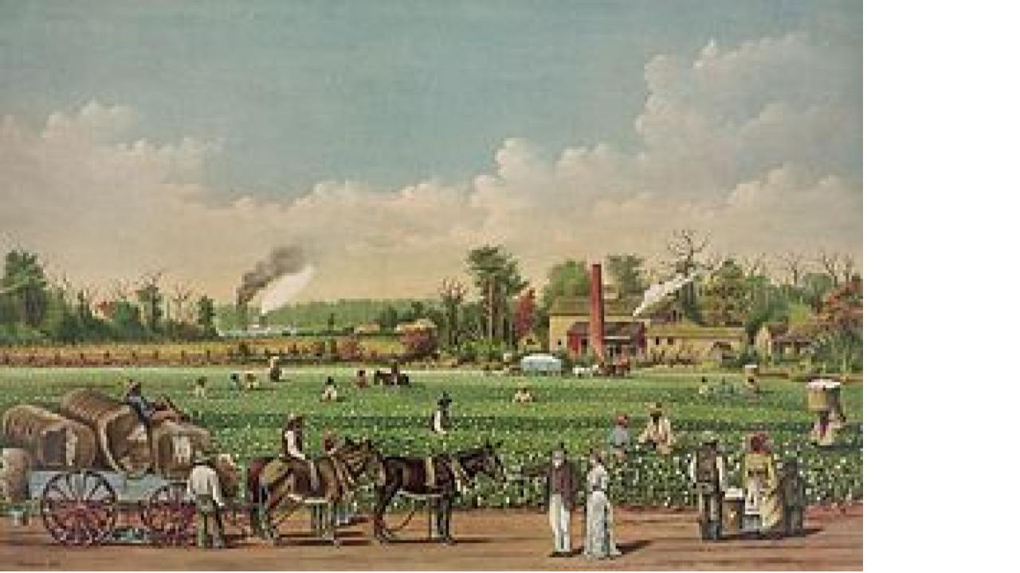 | ____________________________________________________________________________________________________________________________________________________________________________________________________________________________________________________________________________________________________________________________________________________________________________________________________________________________________________________________________________________________________________________________________________________________________________________________________________
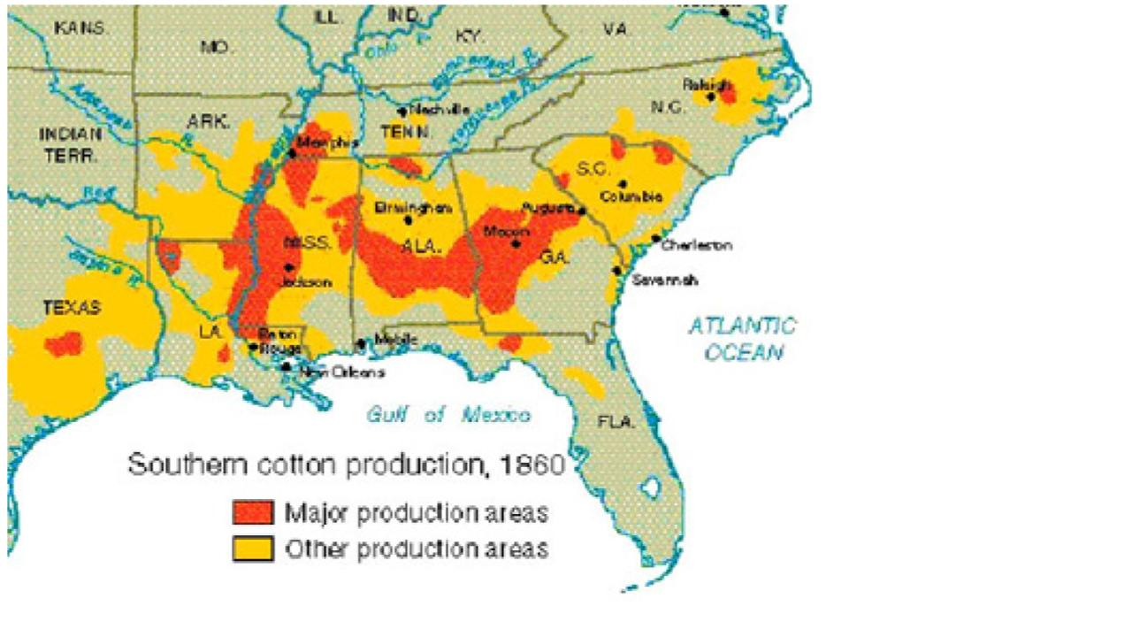 | ____________________________________________________________________________________________________________________________________________________________________________________________________________________________________________________________________________________________________________________________________________________________________________________________________________________________________________________________________________________________________________________________________________________________________________________________________________
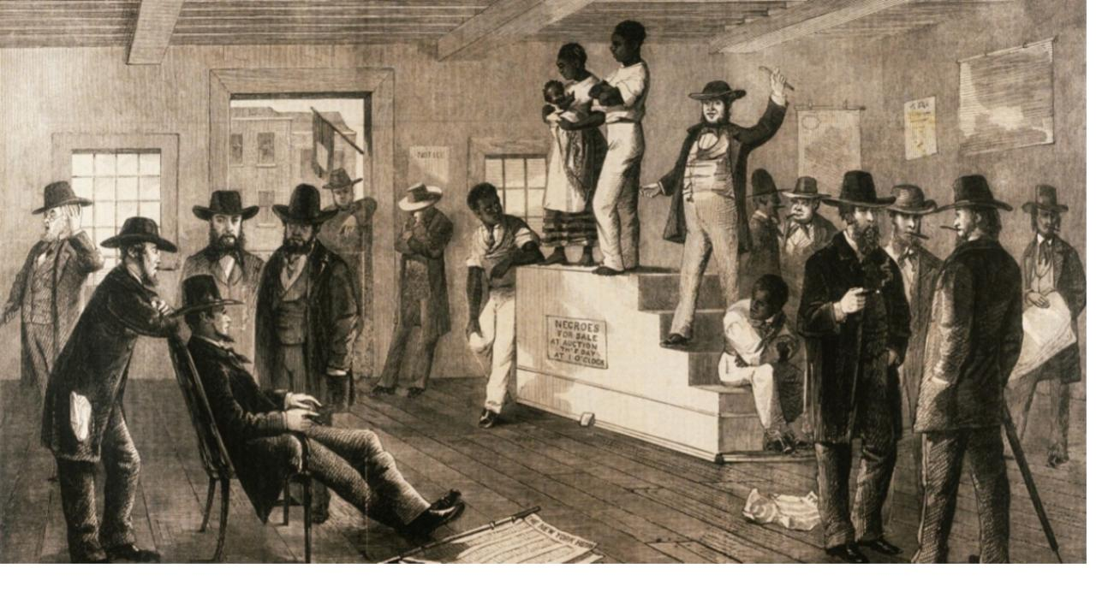 | ____________________________________________________________________________________________________________________________________________________________________________________________________________________________________________________________________________________________________________________________________________________________________________________________________________________________________________________________________________________________________________________________________________________________________________________________________________
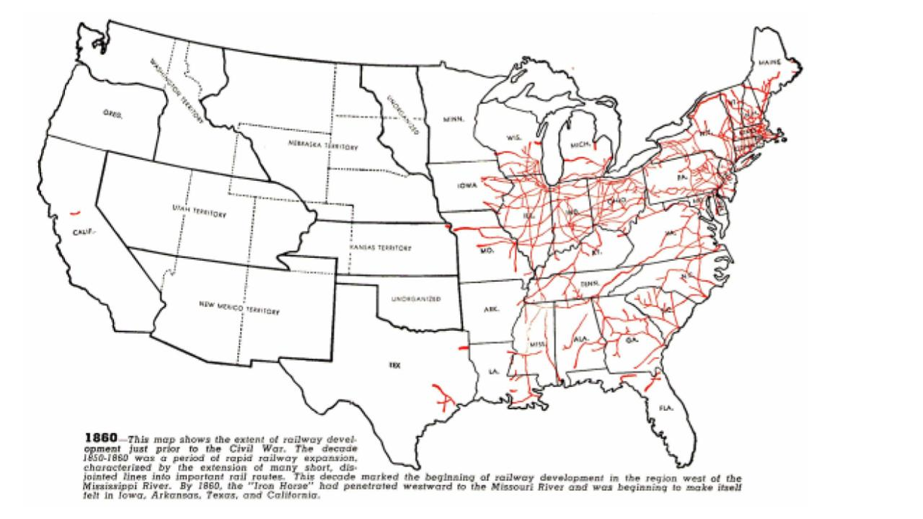 | ____________________________________________________________________________________________________________________________________________________________________________________________________________________________________________________________________________________________________________________________________________________________________________________________________________________________________________________________________________________________________________________________________________________________________________________________________________
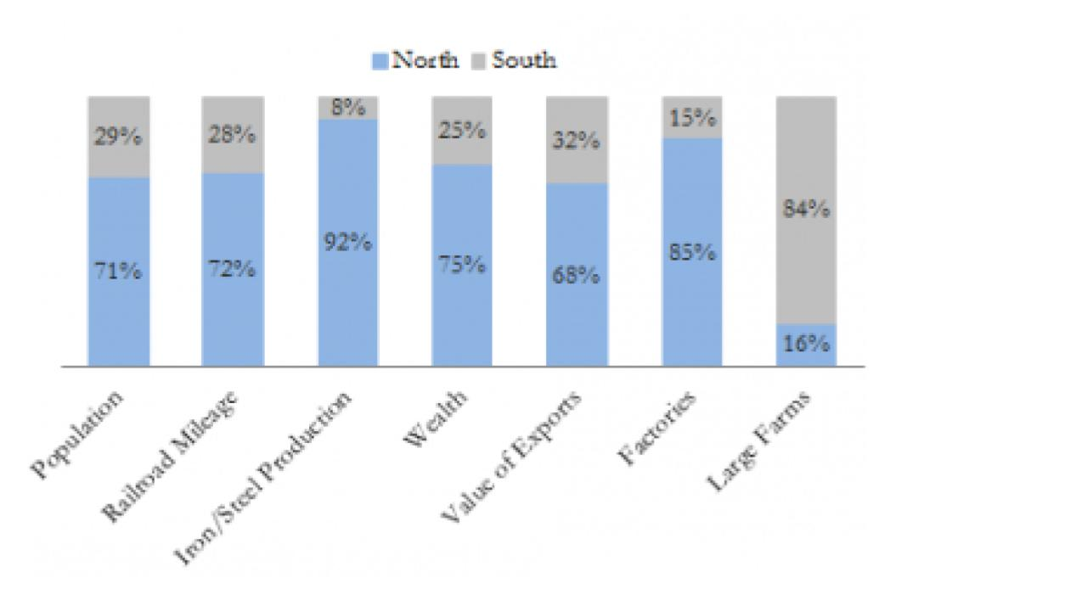 | ____________________________________________________________________________________________________________________________________________________________________________________________________________________________________________________________________________________________________________________________________________________________________________________________________________________________________________________________________________________________________________________________________________________________________________________________________________
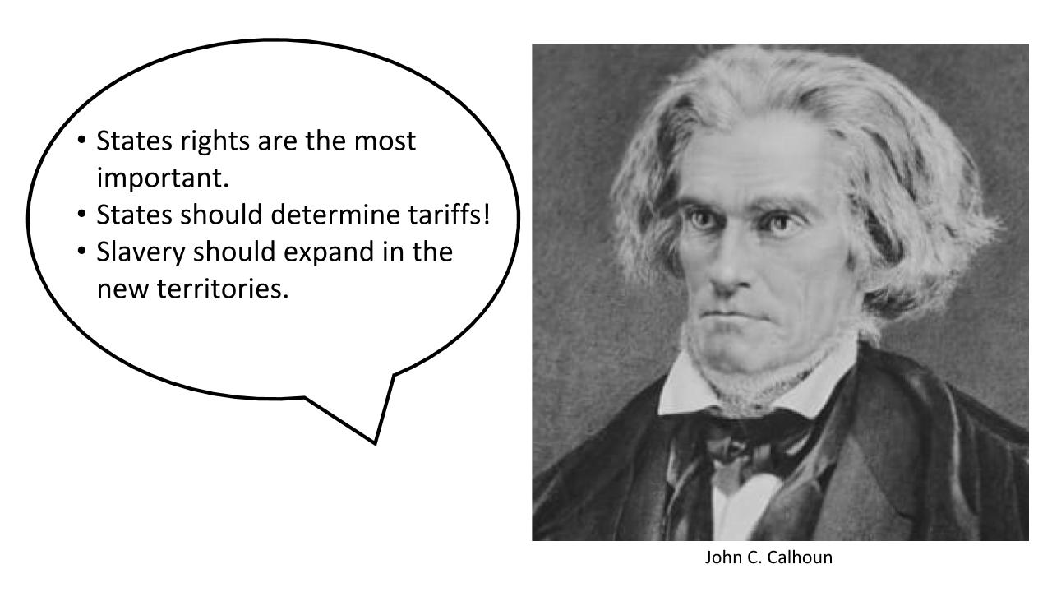 | ____________________________________________________________________________________________________________________________________________________________________________________________________________________________________________________________________________________________________________________________________________________________________________________________________________________________________________________________________________________________________________________________________________________________________________________________________________

- The North
Directions: Use the images below - Describe the characteristic of the northern region of the country that the picture is displaying.

Example: Image 1: Factories were an economic system in the North

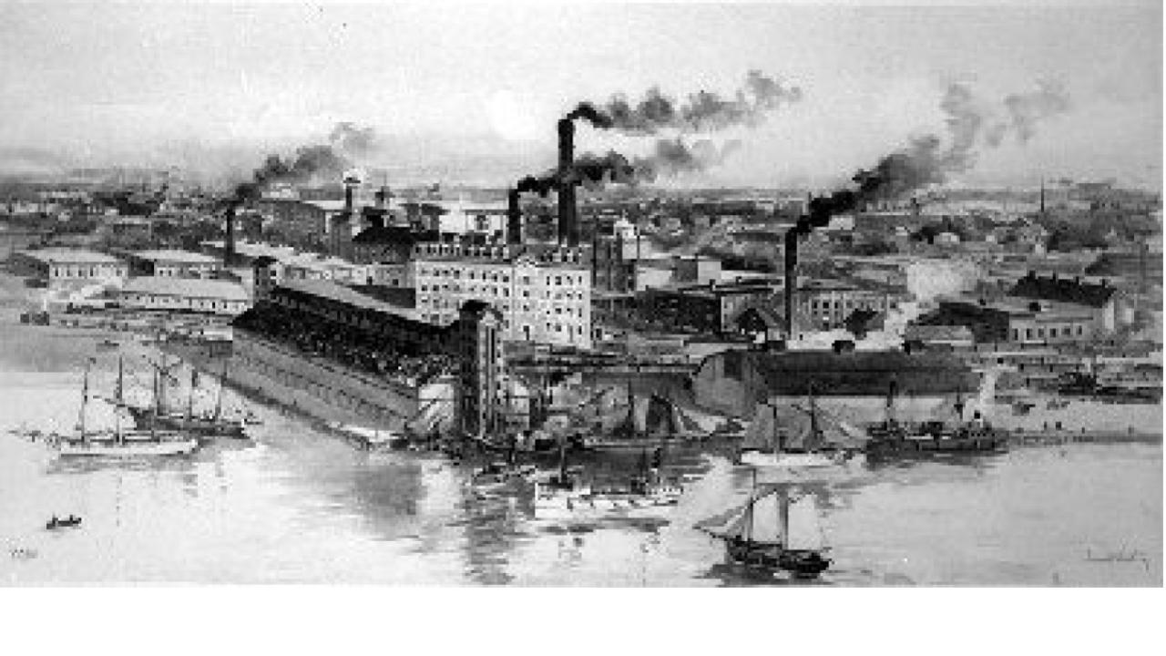 | ____________________________________________________________________________________________________________________________________________________________________________________________________________________________________________________________________________________________________________________________________________________________________________________________________________________________________________________________________________________________________________________________________________________________________________________________________________
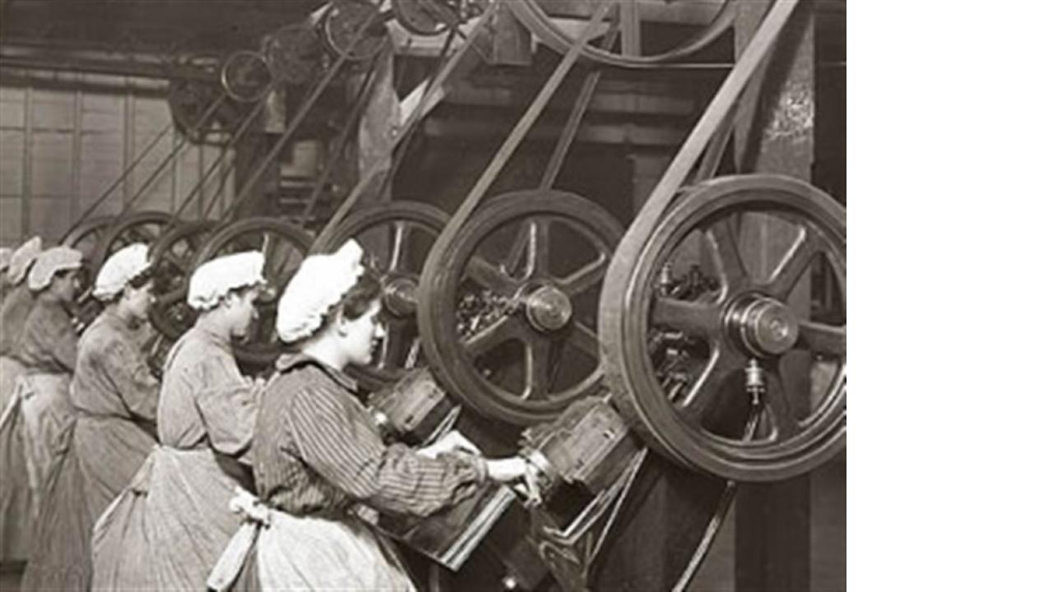 | ____________________________________________________________________________________________________________________________________________________________________________________________________________________________________________________________________________________________________________________________________________________________________________________________________________________________________________________________________________________________________________________________________________________________________________________________________________
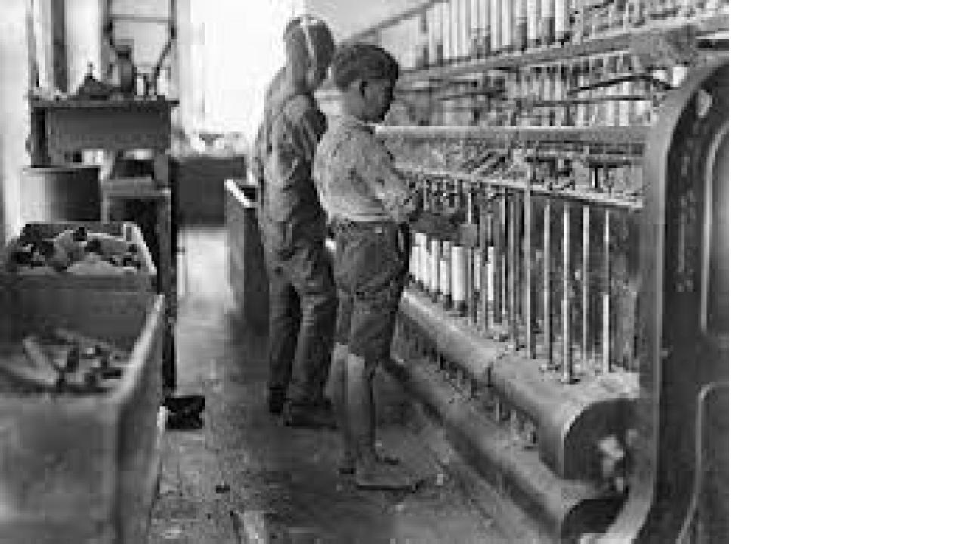 | ____________________________________________________________________________________________________________________________________________________________________________________________________________________________________________________________________________________________________________________________________________________________________________________________________________________________________________________________________________________________________________________________________________________________________________________________________________
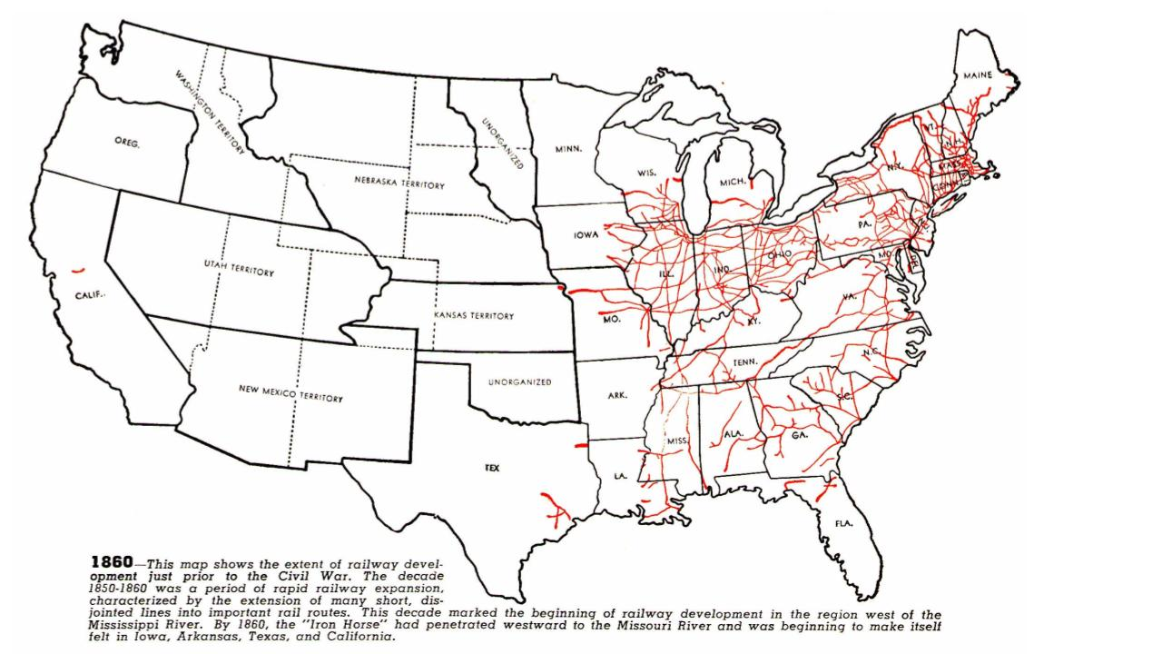 | ____________________________________________________________________________________________________________________________________________________________________________________________________________________________________________________________________________________________________________________________________________________________________________________________________________________________________________________________________________________________________________________________________________________________________________________________________________
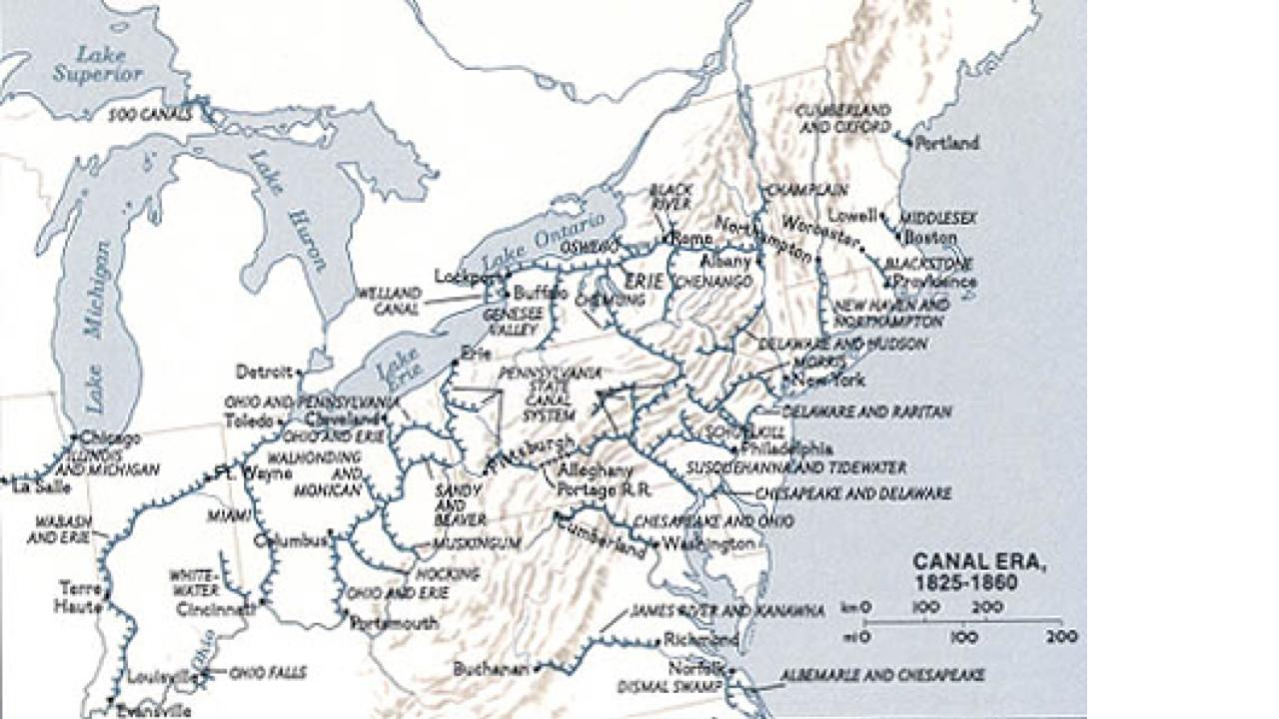 | ____________________________________________________________________________________________________________________________________________________________________________________________________________________________________________________________________________________________________________________________________________________________________________________________________________________________________________________________________________________________________________________________________________________________________________________________________________
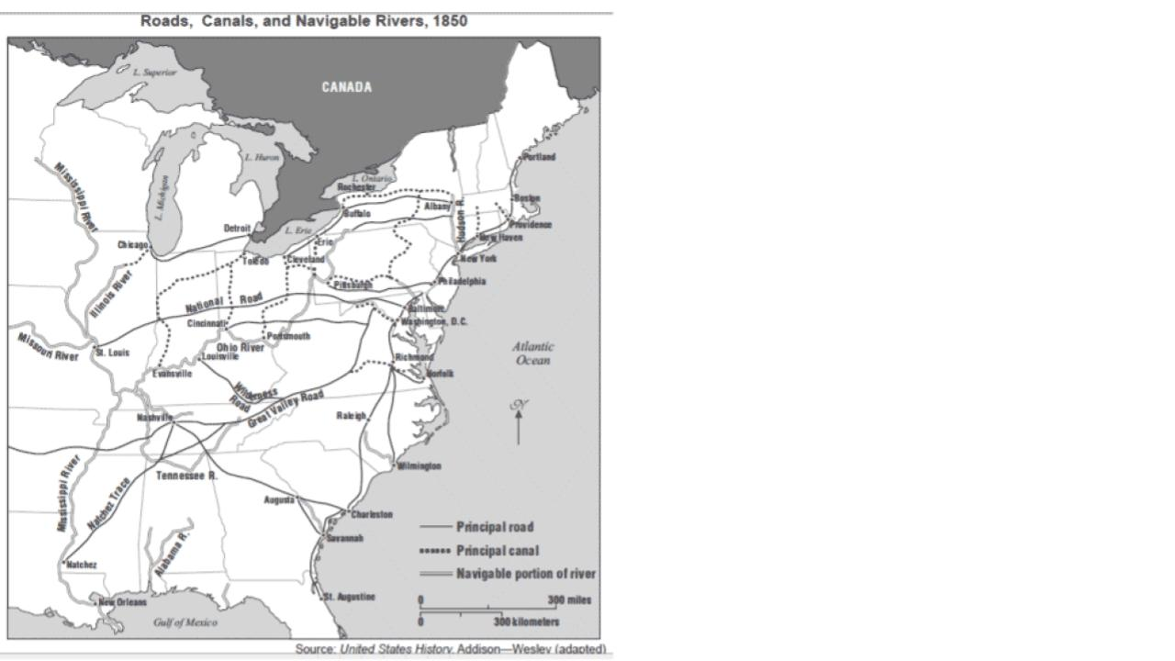 | ____________________________________________________________________________________________________________________________________________________________________________________________________________________________________________________________________________________________________________________________________________________________________________________________________________________________________________________________________________________________________________________________________________________________________________________________________________
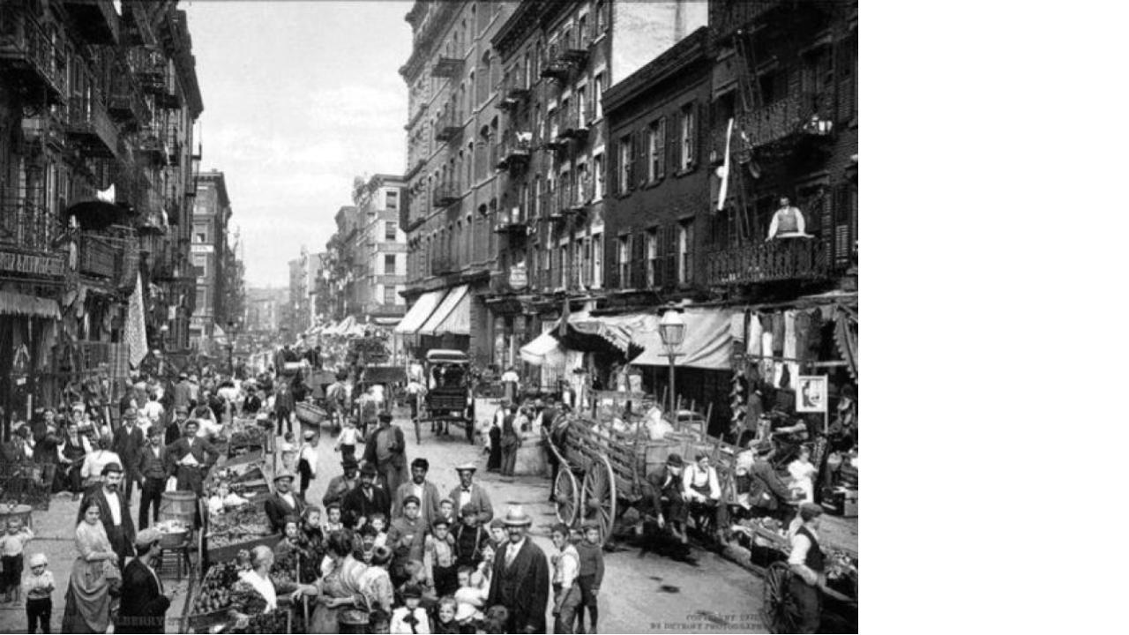 | ____________________________________________________________________________________________________________________________________________________________________________________________________________________________________________________________________________________________________________________________________________________________________________________________________________________________________________________________________________________________________________________________________________________________________________________________________________
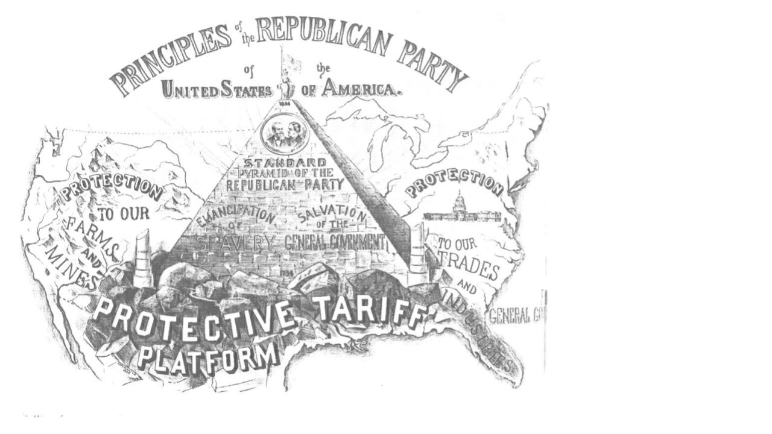 | ____________________________________________________________________________________________________________________________________________________________________________________________________________________________________________________________________________________________________________________________________________________________________________________________________________________________________________________________________________________________________________________________________________________________________________________________________________
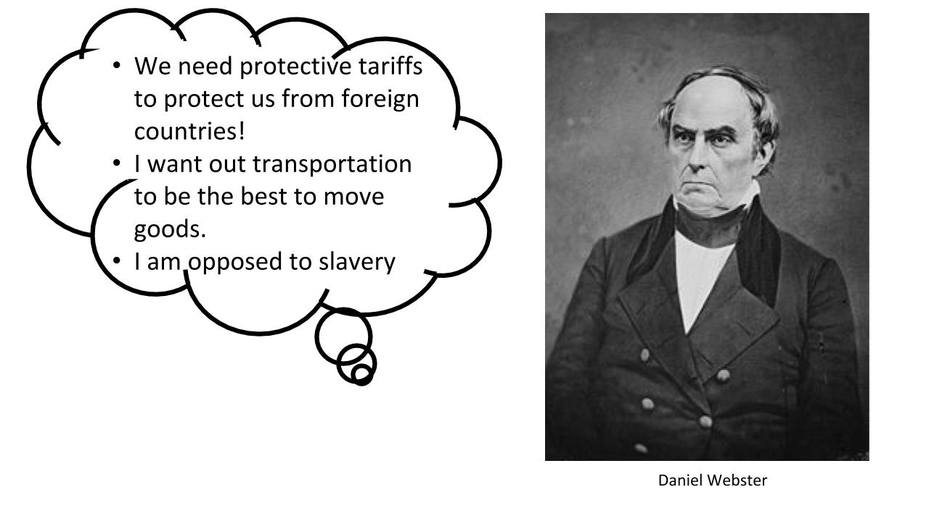 | ____________________________________________________________________________________________________________________________________________________________________________________________________________________________________________________________________________________________________________________________________________________________________________________________________________________________________________________________________________________________________________________________________________________________________________________________________________

Part 3 - Sectionalism Map

North | South | West
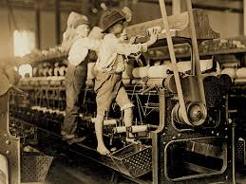 | 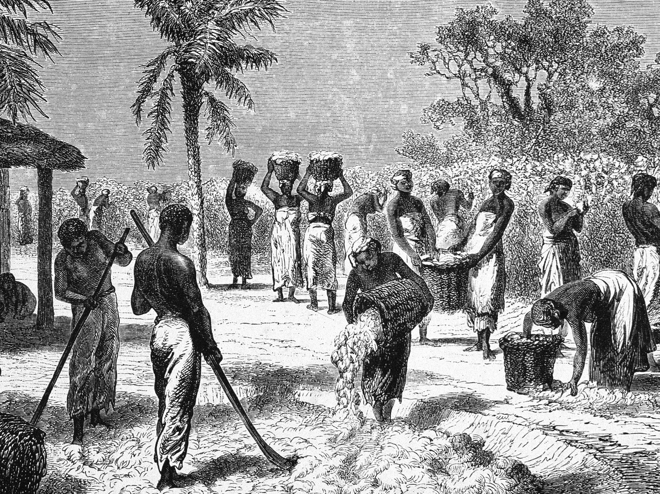
- Industrial Economy  - Support for tariffs- American goods could be sold at lower prices than British goods. | - Agrarian Economy based on agriculture  - Opposition to tariffs, which increased the cost of imported goods | - Emerging Economy  - Support for internal improvements and the sale of public lands

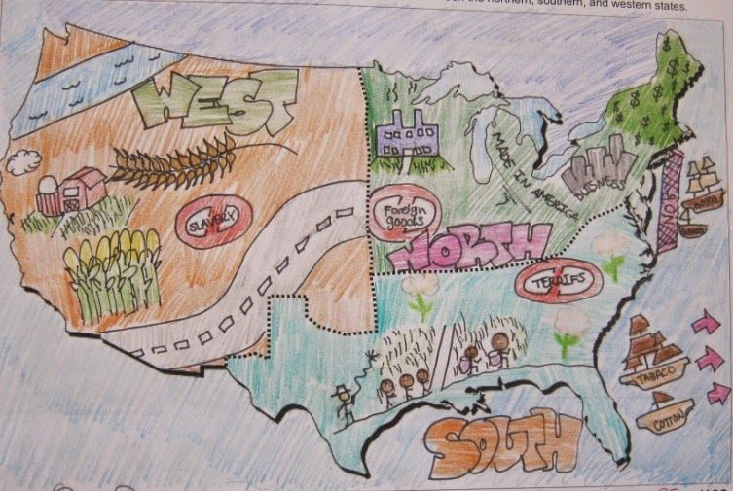
Sectionalism Map Rubric
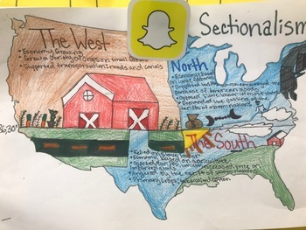
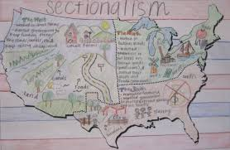
Directions: You will create an authentic sectional map that illustrates the images you analyzed in the Part 2, Sectionalism - Image Analysis. You will first need to draw the shape of the United States or use the United States outline provided on the next page. The paper can be printer paper size or bigger, but not smaller. You will then section off the United States into the North, the South, and the West. For each section you will illustrate three characteristics for that area of the country. For example: in the North, you could draw factories, women workers, and many railroad lines. Below are a few visual examples….do not copy that example. Make your own
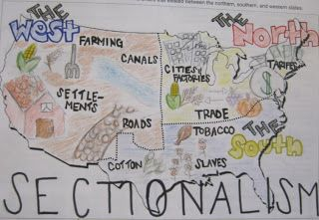
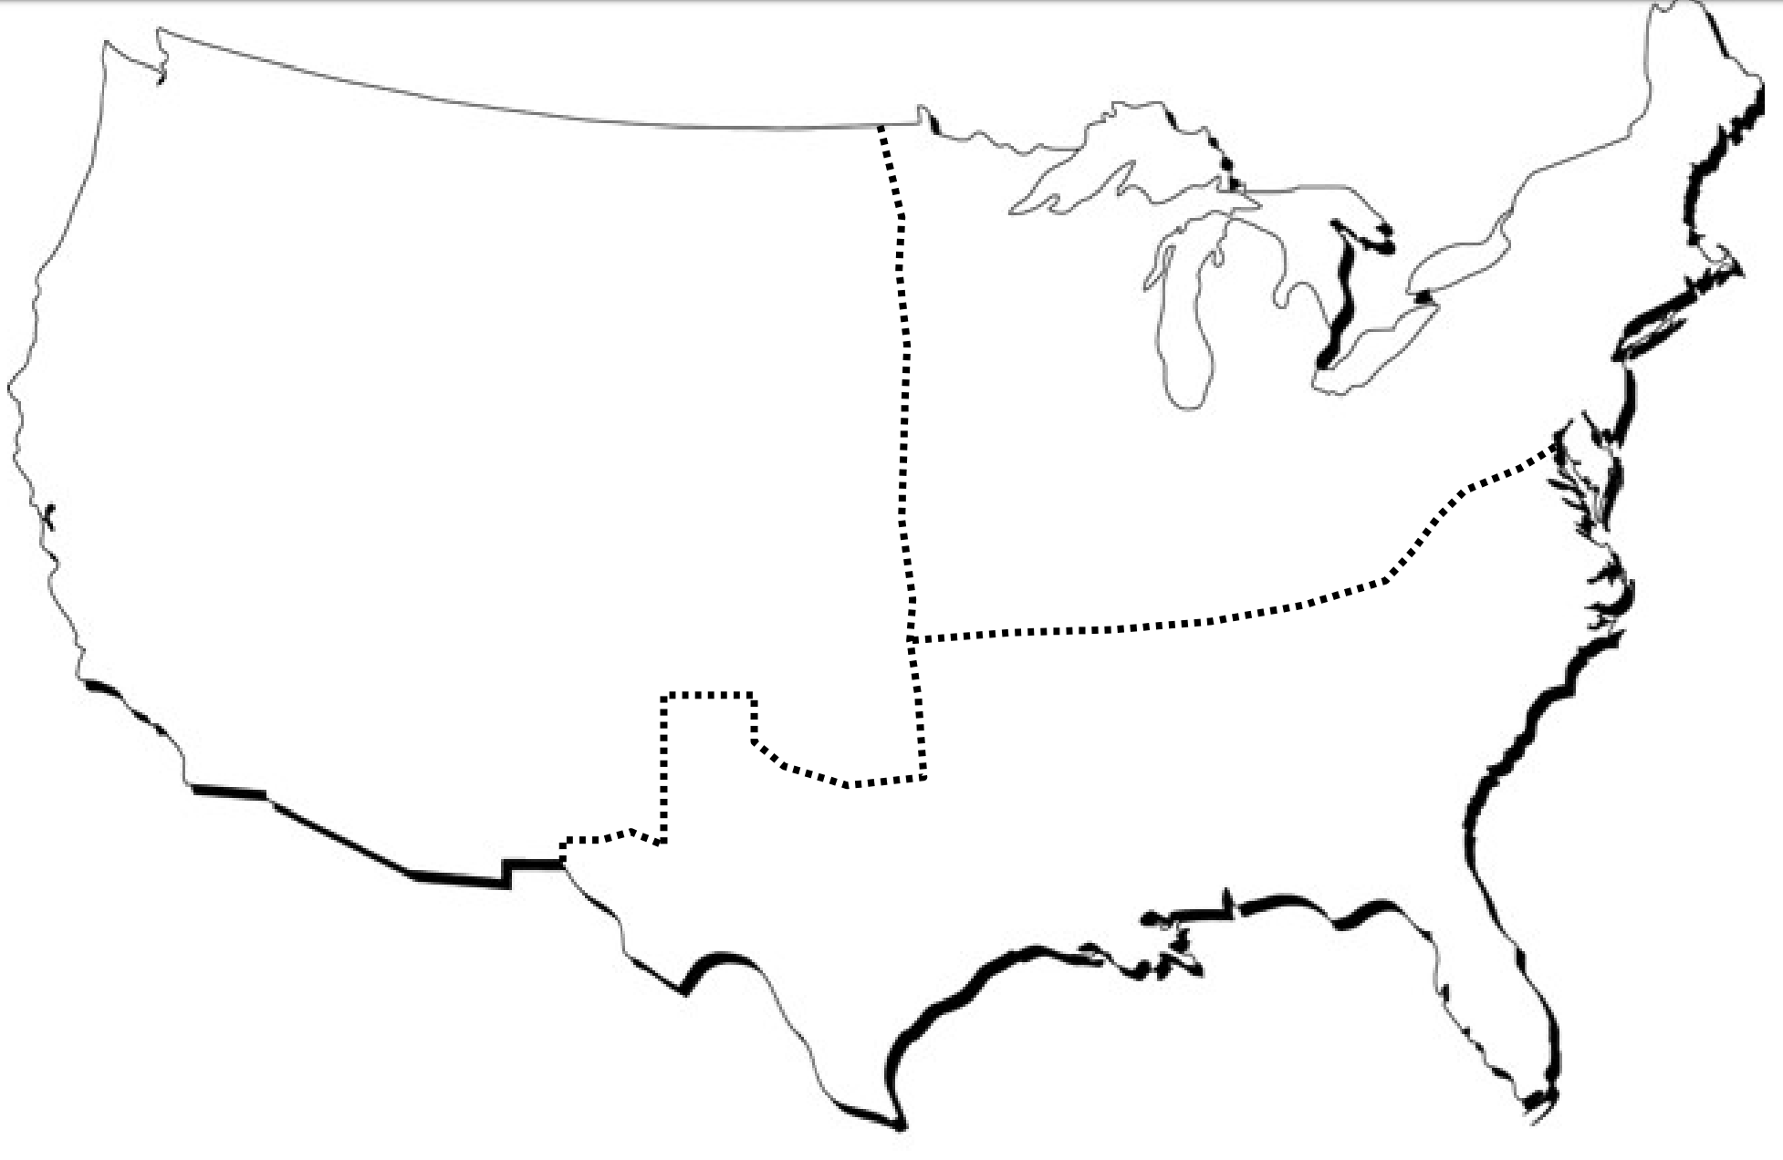
Part 4 - Sectionalism Journal Entry

Answer the following question in a short paragraph (3-5 sentences.)
How did sectionalism lead to the Civil War?
Stem: Sectionalism led to the Civil War by...
_____________________________________________________________________________________________________________________________________________________________________________________________________________________________________________________________________________________________________________________________________________________________________________________________________________________________________________________________________________________________________________________________________________________________________________________________________________________________________________________________________________________________________________________________________________________________________________________________________________________________________________________________________________________________________________________________________________________________________________________________________________________________________________________.

