Sectionalism Map Rubric
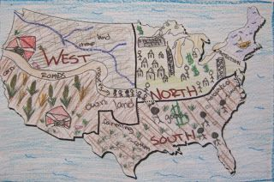
Directions: You will create an authentic sectional map that illustrates the images you analyzed in the separate attachment. You will first need to draw the shape of the United States or copy and paste a United States outline on a document or on paper you have in your home. The paper can be printer paper size or bigger, but not smaller. You will then section off the United States into the North, the South, and the West. For each section you will illustrate three characteristics for that area of the country. For example: in the North, you could draw factories, women workers, and many railroad lines. Below is a visual example….do not copy that example. Make your own.

Grade: Map labeled with each region 40 points _____/40
Each region has at least three images that represent its characteristics 40 points _____/40
The map is colored and neat 20 points _______/20

